Cylinder of Revolution
# Source: AI Source: Provided by: [Data Path: Persons Table -> ID Column: 1, Name_En Column: Motasem Essam] -> From: [ChatGPT] on [7/25/2026]
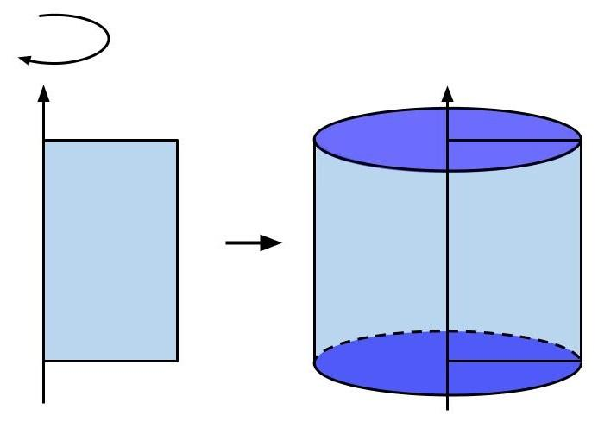
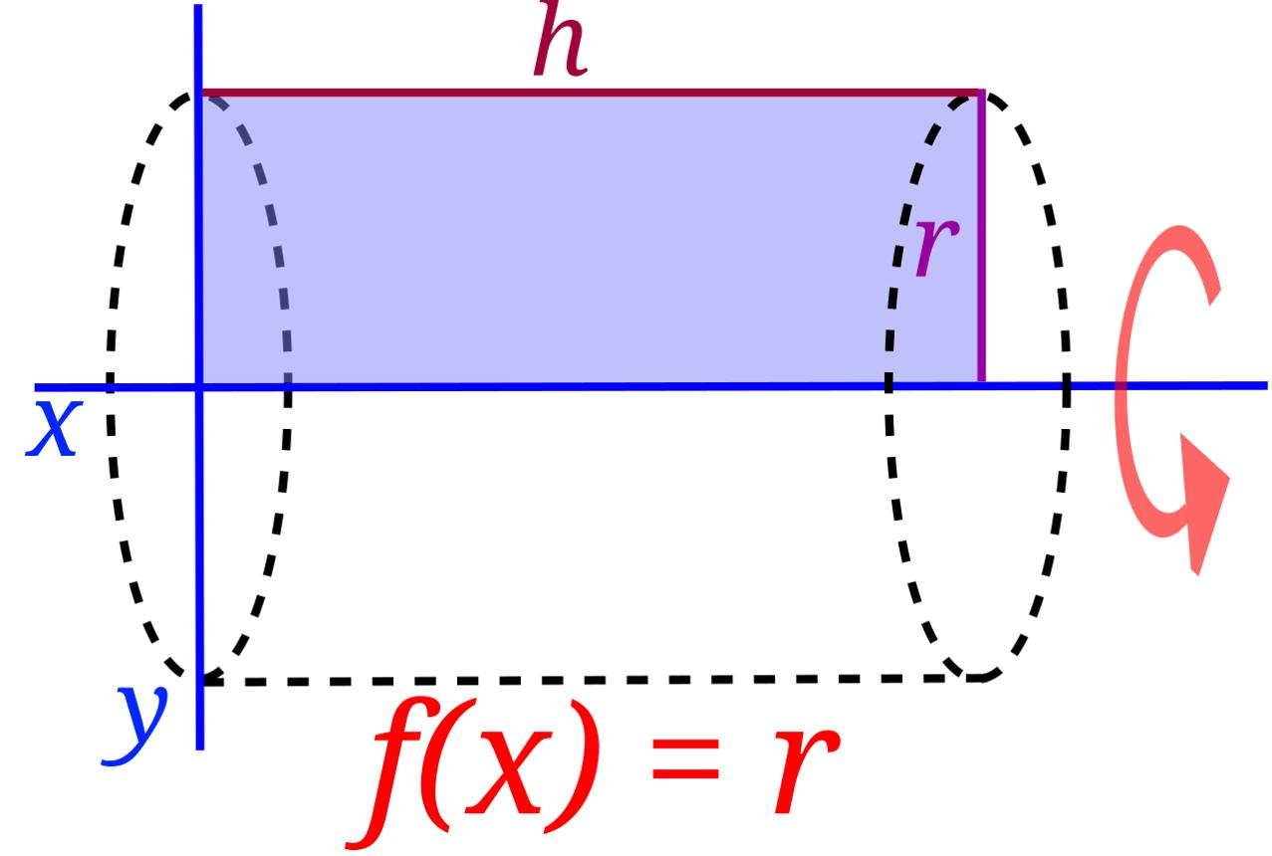
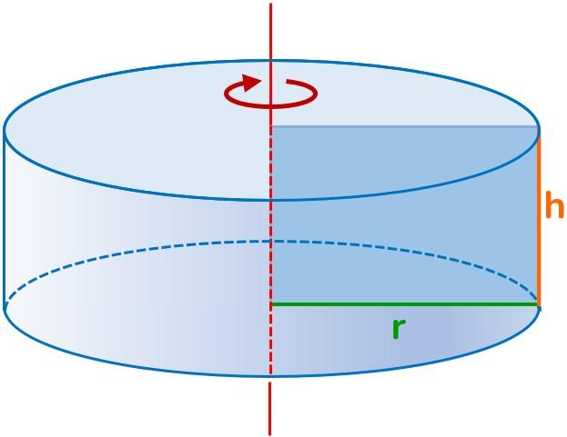

Definition
# Source: AI Source: Provided by: [Data Path: Persons Table -> ID Column: 1, Name_En Column: Motasem Essam] -> From: [ChatGPT] on [7/25/2026]
A cylinder of revolution is a three-dimensional solid generated by rotating a rectangle through one complete revolution of $360^\backslash circ$ about one of its sides.
The side used as the axis of rotation becomes the cylinder's axis, while the opposite side traces the curved lateral surface. The two remaining sides sweep out the circular bases.
A cylinder of revolution is therefore a right circular cylinder.

Simple Definition
# Source: AI Source: Provided by: [Data Path: Persons Table -> ID Column: 1, Name_En Column: Motasem Essam] -> From: [ChatGPT] on [7/25/2026]
A cylinder of revolution is a cylinder made by spinning a rectangle around one of its sides.
For example, rotating a rectangle around one vertical side produces a cylinder with circular top and bottom faces and a curved lateral surface.

How a Cylinder of Revolution Is Formed
# Source: AI Source: Provided by: [Data Path: Persons Table -> ID Column: 1, Name_En Column: Motasem Essam] -> From: [ChatGPT] on [7/25/2026]
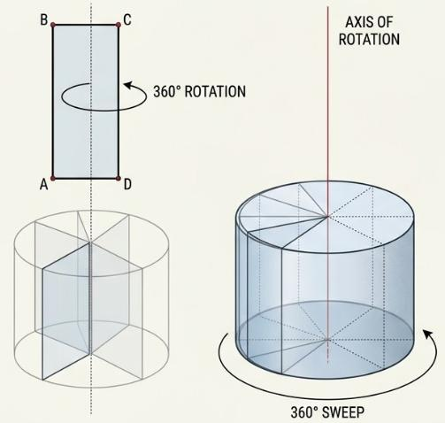
The construction proceeds as follows:
- Start with a rectangle.
- Select one of its sides as the axis of revolution.
- Rotate the rectangle around that side through ${360}^{∘}$.
- The rectangle sweeps out a right circular cylinder.
If the rectangle has height $h$ and width $r$, then:
- The chosen side is the cylinder's axis.
- The rectangle's width becomes the radius $r$.
- The rectangle's height becomes the cylinder's height $h$.
- The opposite side traces the cylindrical lateral surface.

Key Characteristics
# Source: AI Source: Provided by: [Data Path: Persons Table -> ID Column: 1, Name_En Column: Motasem Essam] -> From: [ChatGPT] on [7/25/2026]
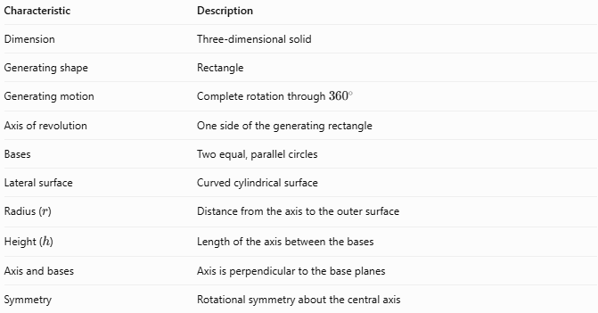
Characteristic | Description
Dimension | Three-dimensional solid
Generating shape | Rectangle
Generating motion | Complete rotation through \(360^\circ\)
Axis of revolution | One side of the generating rectangle
Bases | Two equal, parallel circles
Lateral surface | Curved cylindrical surface
Radius ($r$) | Distance from the axis to the outer surface
Height ($h$) | Length of the axis between the bases
Axis and bases | Axis is perpendicular to the base planes
Symmetry | Rotational symmetry about the central axis

Geometric Components
# Source: AI Source: Provided by: [Data Path: Persons Table -> ID Column: 1, Name_En Column: Motasem Essam] -> From: [ChatGPT] on [7/25/2026]

- Upper base: The top circular face.
- Lower base: The bottom circular face.
- Axis of revolution: The central line about which the rectangle rotates.
- Radius ($r$): Distance from the axis to the circumference of a base.
- Diameter ($d$): Distance across a base through its center.
- Height ($h$): Perpendicular distance between the base planes.
- Lateral surface: The curved surface connecting the two circular bases.

Mathematical Representations and Formulas
# Source: AI Source: Provided by: [Data Path: Persons Table -> ID Column: 1, Name_En Column: Motasem Essam] -> From: [ChatGPT] on [7/25/2026]
Let $r$ represent the radius and $h$ represent the height.

Diameter
# Source: AI Source: Provided by: [Data Path: Persons Table -> ID Column: 1, Name_En Column: Motasem Essam] -> From: [ChatGPT] on [7/25/2026]
$$d=2r$$

Base Area
# Source: AI Source: Provided by: [Data Path: Persons Table -> ID Column: 1, Name_En Column: Motasem Essam] -> From: [ChatGPT] on [7/25/2026]
Each circular base has area:
$$\boxed{A_{B}=πr^{2}}$$

Volume
# Source: AI Source: Provided by: [Data Path: Persons Table -> ID Column: 1, Name_En Column: Motasem Essam] -> From: [ChatGPT] on [7/25/2026]
The volume equals the base area multiplied by the height:
$$V=A_{B}h$$
Therefore:
$$\boxed{V=πr^{2}h}$$

Curved Surface Area
# Source: AI Source: Provided by: [Data Path: Persons Table -> ID Column: 1, Name_En Column: Motasem Essam] -> From: [ChatGPT] on [7/25/2026]
When the curved lateral surface is unfolded, it forms a rectangle with width $2πr$ and height $h$.
$$\boxed{A_{L}=2πrh}$$

Total Surface Area
# Source: AI Source: Provided by: [Data Path: Persons Table -> ID Column: 1, Name_En Column: Motasem Essam] -> From: [ChatGPT] on [7/25/2026]
For a closed cylinder, add the curved surface and the two circular bases:
$$A_{T}=2πrh+2πr^{2}$$
Therefore:
$$\boxed{A_{T}=2πr\left(h+r\right)}$$

Circumference of a Base
# Source: AI Source: Provided by: [Data Path: Persons Table -> ID Column: 1, Name_En Column: Motasem Essam] -> From: [ChatGPT] on [7/25/2026]
$$\boxed{C=2πr=πd}$$

Worked Examples
# Source: AI Source: Provided by: [Data Path: Persons Table -> ID Column: 1, Name_En Column: Motasem Essam] -> From: [ChatGPT] on [7/25/2026]
Example 1: Calculate the Volume
A cylinder of revolution has radius $r=4\text{ cm}$ and height $h=10\text{ cm}$. Find its volume.
Solution
$$V=πr^{2}h$$
$$V=π{\left(4\right)}^{2}\left(10\right)$$
$$\boxed{V=160π{\text{ cm}}^{3}≈502.65{\text{ cm}}^{3}}$$
Example 2: Calculate the Curved Surface Area
A cylinder has radius $r=3\text{ cm}$ and height $h=8\text{ cm}$. Find its curved surface area.
Solution
$$A_{L}=2πrh$$
$$A_{L}=2π\left(3\right)\left(8\right)$$
$$\boxed{A_{L}=48π{\text{ cm}}^{2}≈150.80{\text{ cm}}^{2}}$$
Example 3: Calculate the Total Surface Area
A closed cylinder has radius $r=5\text{ cm}$ and height $h=12\text{ cm}$. Find its total surface area.
Solution
$$A_{T}=2πr\left(h+r\right)$$
$$A_{T}=2π\left(5\right)\left(12+5\right)$$
$$\boxed{A_{T}=170π{\text{ cm}}^{2}≈534.07{\text{ cm}}^{2}}$$

Comparison with Related Solids
# Source: AI Source: Provided by: [Data Path: Persons Table -> ID Column: 1, Name_En Column: Motasem Essam] -> From: [ChatGPT] on [7/25/2026]
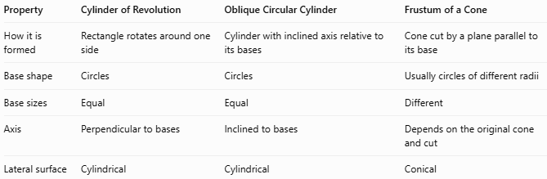
Property | Cylinder of Revolution | Oblique Circular Cylinder | Frustum of a Cone
How it is formed | Rectangle rotates around one side | Cylinder with inclined axis relative to its bases | Cone cut by a plane parallel to its base
Base shape | Circles | Circles | Usually circles of different radii
Base sizes | Equal | Equal | Different
Axis | Perpendicular to bases | Inclined to bases | Depends on the original cone and cut
Lateral surface | Cylindrical | Cylindrical | Conical

Applications
# Source: AI Source: Provided by: [Data Path: Persons Table -> ID Column: 1, Name_En Column: Motasem Essam] -> From: [ChatGPT] on [7/25/2026]
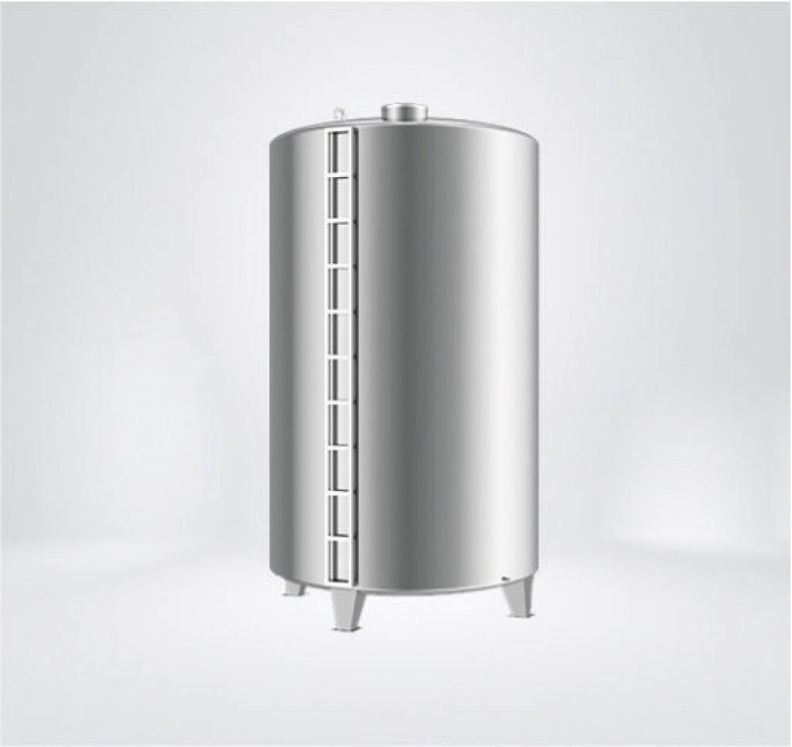
Storage Tanks
Cylindrical tanks are modeled using radius, height, volume, and surface-area formulas.
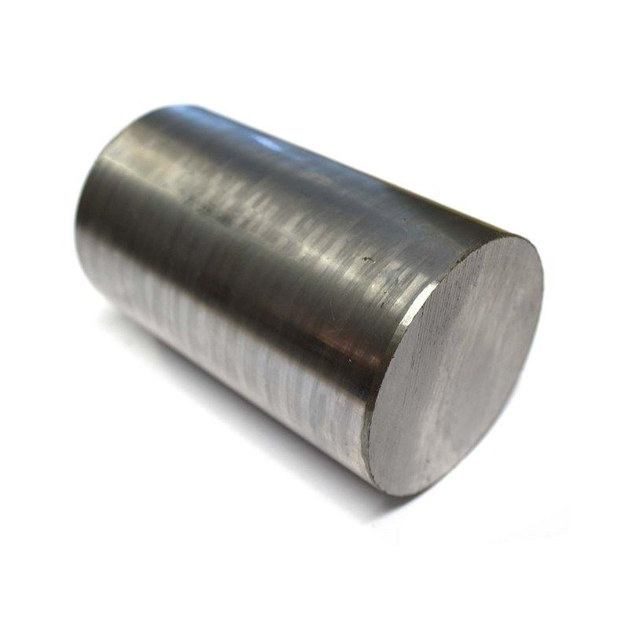
Mechanical Engineering
Cylindrical rods, shafts, and machine parts use the geometry of right circular cylinders.
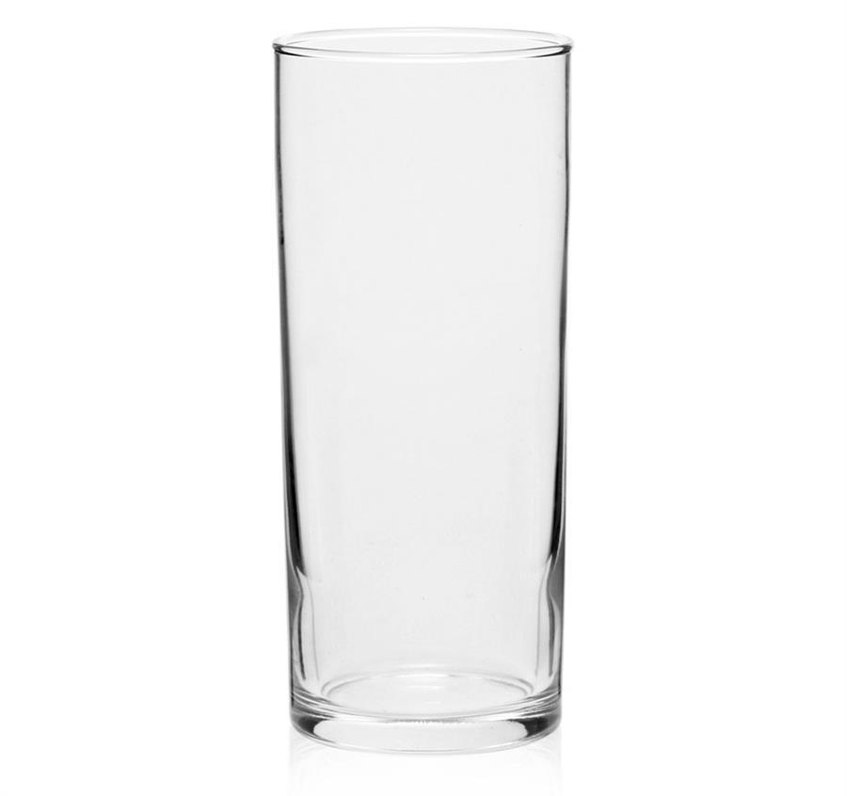
Containers
Glasses, cans, and containers often approximate the shape of a cylinder of revolution.

Key Points
# Source: AI Source: Provided by: [Data Path: Persons Table -> ID Column: 1, Name_En Column: Motasem Essam] -> From: [ChatGPT] on [7/25/2026]
- A cylinder of revolution is generated by rotating a rectangle through ${360}^{∘}$ around one of its sides.
- It is a type of right circular cylinder.
- The axis of revolution is perpendicular to the circular base planes.
- The rectangle's width determines the radius, and its side along the axis determines the height.
- The volume is $V=πr^{2}h$.
- The total surface area of a closed cylinder is $A_{T}=2πr\left(h+r\right)$.

Conclusion
# Source: AI Source: Provided by: [Data Path: Persons Table -> ID Column: 1, Name_En Column: Motasem Essam] -> From: [ChatGPT] on [7/25/2026]
A cylinder of revolution is a right circular cylinder formed by rotating a rectangle around one of its sides. This connection between a two-dimensional rectangle and a three-dimensional solid provides a simple way to understand the cylinder's shape, symmetry, dimensions, and formulas. It is a fundamental concept in solid geometry and in practical applications involving cylindrical objects.

